**Password Reset**

Click here to see the menu and select Passwrd & Security

To reset your email password, login using webmail

[www.wpc.ac.sz/webmail](http://www.wpc.ac.sz/webmail)

Type your current password and you will default to the page below:

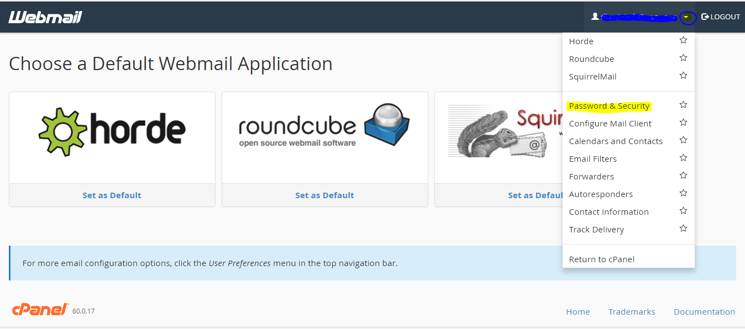

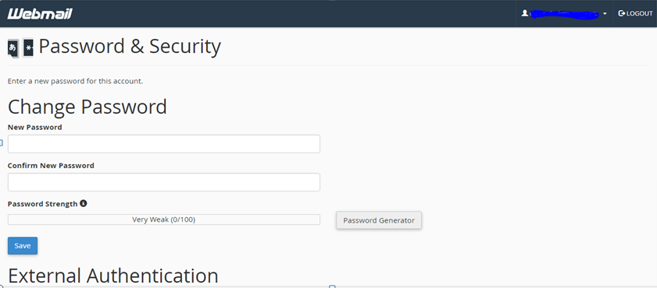

Type your desired password here.